WEEK – 2 Date: 19/10/2021

1. Aim: Write a program to implement binary search method using recursive and non-recursive method.

Program:

1. With recursion

def binary_search(arr,l,h,key):

if(h>=1):

m = (l+h)//2

if(arr[m]==key):

return m

elif(arr[m]<key):

return binary_search(arr,m+1,h,key)

else:

return binary_search(arr,l,m-1,key)

print("Enter the elements in ascending order:")

l=[int(x) for x in input().split()]

key = int(input("Enter the element to be searched:"))

a=binary_search(l,0,len(l)-1,key)

print(str(key)+" Found at "+str(a))

1. Without recursion

def binary_search(arr,l,h,key):

while(l<=h):

m = (l+h)//2

if(arr[m]==key):

return m

elif(arr[m]<key):

l = m+1

else:

h = m-1

print("Enter the elements in ascending order:")

l=[int(x) for x in input().split(' ')]

key = int(input("Enter the element to be searched:"))

a=binary_search(l,0,len(l)-1,key)

print(str(key)+" Found at "+str(a))

**Output**:

1. Without recursion:



1. With recursion:

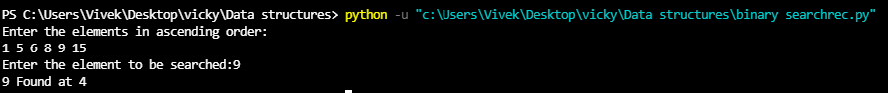

1. **Aim**: Write a program to implement selection sort using recursive method.

**Program:**

def minindex(arr,i,j):

if i==j:

return i

k = minindex(arr,i+1,j)

return(i if arr[i]<arr[k] else k)

def selection_sort(arr,n,index=0):

if index == n:

return -1

k = minindex(arr,index,n-1)

if k!=index:

arr[k],arr[index] = arr[index],arr[k]

selection_sort(arr,n,index+1)

l = []

n = int (input("Enter the range: "))

print("Enter the numbers: ")

for i in range(n):

x = int(input())

l.append(x)

selection_sort(l,len(l))

print(l)

**Output**:

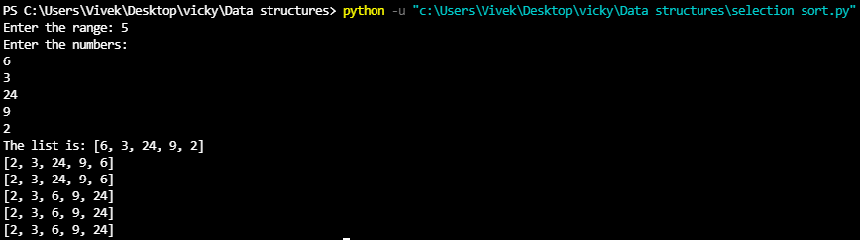

1. **Aim**: Write a program to implement linear search method using recursive method.

**Program:**

a=list()

FOUND=0

n=int(input("How many numbers: "))

if(n>10):

print("\nToo many Numbers\n")

print("\nEnter the array elements\n")

for i in range(n):

y=int(input("Enter the elements: "))

a.append(y)

key=int(input("\nEnter the key to be searched\n"))

for i in range(n):

if(a[i]==key):

print("Found at",i)

FOUND=1

break

if(FOUND==0):

print("\nNOT FOUND...")

**Output**:

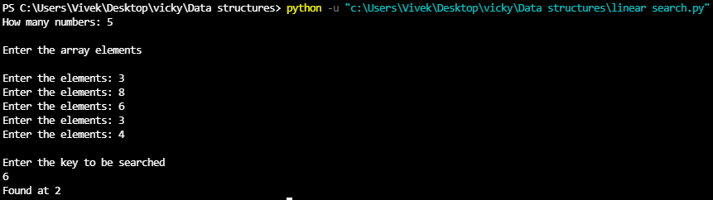

1. **Aim**: Write a program to implement towers of Hanoi

**Program:**

def TowerOfHanoi(n , from_rod, to_rod, aux_rod):

if n == 1:

print("Move disk 1 from rod",from_rod,"to rod",to_rod)

return

TowerOfHanoi(n-1, from_rod, aux_rod, to_rod)

print("Move disk",n,"from rod",from_rod,"to rod",to_rod)

TowerOfHanoi(n-1, aux_rod, to_rod, from_rod)

n = int(input("Enter the no of disks:"))

TowerOfHanoi(n, 'A', 'C', 'B')

**Output**:

